**Homework 2**

**(100 points)**

**Due Date: on elearning**

**Submit: eLearning**

**Late Policy: 10% per day late**

**Instructions: Include Name and Net ID. This is an individual assignment. Answers should be your own work.**

1. Let R be the relation {(a, b) | a != b} on the set of integers. What is the reflexive closure of R? (5 points)
2. Which of these relations on the set of all people are equivalence relations? Determine the properties of an equivalence relation that the others lack. (20 points, 4 each)

a) {(a, b) | a and b are the same age}

b) {(a, b) | a and b have the same parents}

c) {(a, b) | a and b share a common parent}

d) {(a, b) | a and b have met}

e) {(a, b) | a and b speak a common language}

1. Find equivalence classes of following relations if they exist. (25 points, 5 each)

a) {(0, 0), (1, 1), (2, 2), (3, 3)}

b) {(0, 0), (0, 2), (2, 0), (2, 2), (2, 3), (3, 2), (3, 3)}

c) {(0, 0), (1, 1), (1, 2), (2, 1), (2, 2), (3, 3)}

d) {(0, 0), (1, 1), (1, 3), (2, 2), (2, 3), (3, 1), (3, 2), (3, 3)}

e) {(0, 0), (0, 1), (0, 2), (1, 0), (1, 1), (1, 2), (2, 0), (2, 2), (3, 3)}

1. Find reflexive closure graph, symmetric closure graph and transitive closure graph for following graphs (20 points)

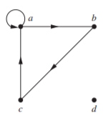

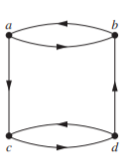

1. 25 points (5 each)

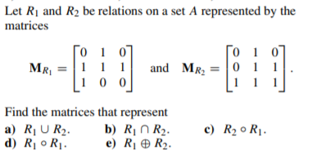

1. 5 points

